**Electronics Components**

**LDR (Light Dependent Resistor)**

LDR is a passive component which changes its resistance due to the intensity of light. When intensity of light increases, the resistance of LDR gradually decreases, this change allows the flow of current through the LDR. 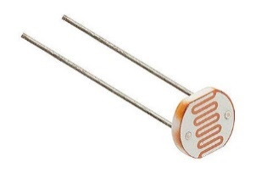

**Resistor**

Resistor is called a fixed resistor as its value remains same regardless of the voltage across it. It limits the current flow from one end to the other end as per its value, higher the resistance value lower the current flow across it.

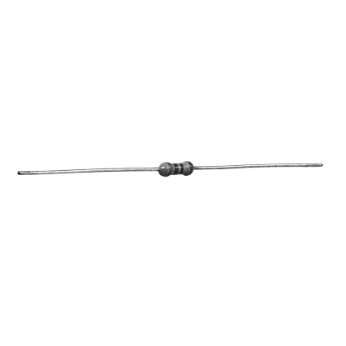

**Transistor**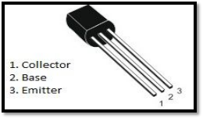

Transistor is a semiconductor element used for amplifying signals and switching circuits. It has 3 terminals named as **Collector** which collects the current, **Emitter** which emits the current and **Base** which allows or stops the flow of current from Collector to Emitter terminal.

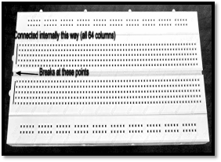

**Breadboard**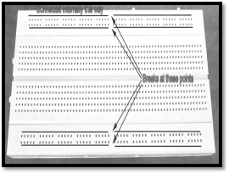

Breadboard is a platform to build basic to advanced level of circuits for testing and implementation. It has 3 main sections, the upper and bottom section dots are horizontally short-circuited, the middle section is subdivided into two parts again explicitly vertically connected from the inside. Its used to reduce wires as well as simplify the use of ICs.

**DPDT Relay**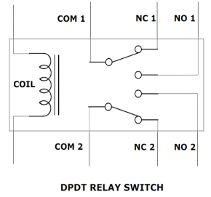

DPDT relay is an electromechanical switch used for controlling a separate block of components. Double pole resembles that there are two polarities (+, -) at the input end and double throw means each polarity with two outputs. This relay has 8 pins as two pins are required for the coil.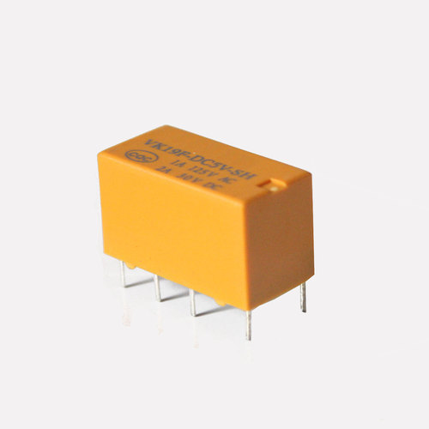

**Breadboard:-**

A breadboard is a solderless device for temporary prototype with electronics and test circuit designs. Most electronic components in electronic circuits can be interconnected by inserting their leads or terminals into the holes and then making connections through wires where appropriate.

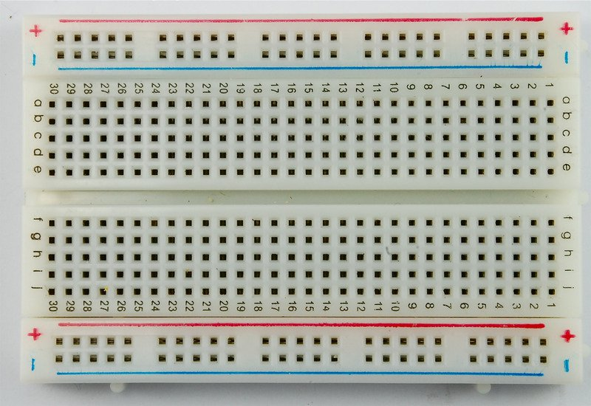

**Printed circuit board:-**

PCB is an electronic circuit consisting of thin strips of a conducting material such as copper, which have been etched from a layer fixed to a flat insulating sheet called a printed circuit board, and to which integrated circuits and other components are attached.

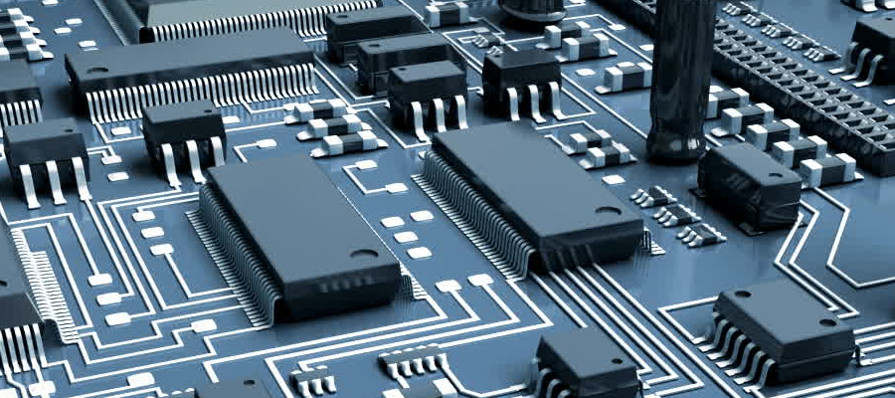

**Jumper wires:-**

A jumper wire is an [electrical wire](https://en.wikipedia.org/wiki/Electrical_wire), or group of them in a cable, with a connector or pin at each end (or sometimes without them – simply "tinned"), which is normally used to interconnect the components of a [breadboard](https://en.wikipedia.org/wiki/Breadboard) or other prototype or test circuit, internally or with other equipment or components, without soldering.

Individual jump wires are fitted by inserting their "end connectors" into the slots provided in a breadboard, the [header connector](https://en.wikipedia.org/wiki/Pin_header#Header_connector) of a circuit board, or a piece of test equipment.

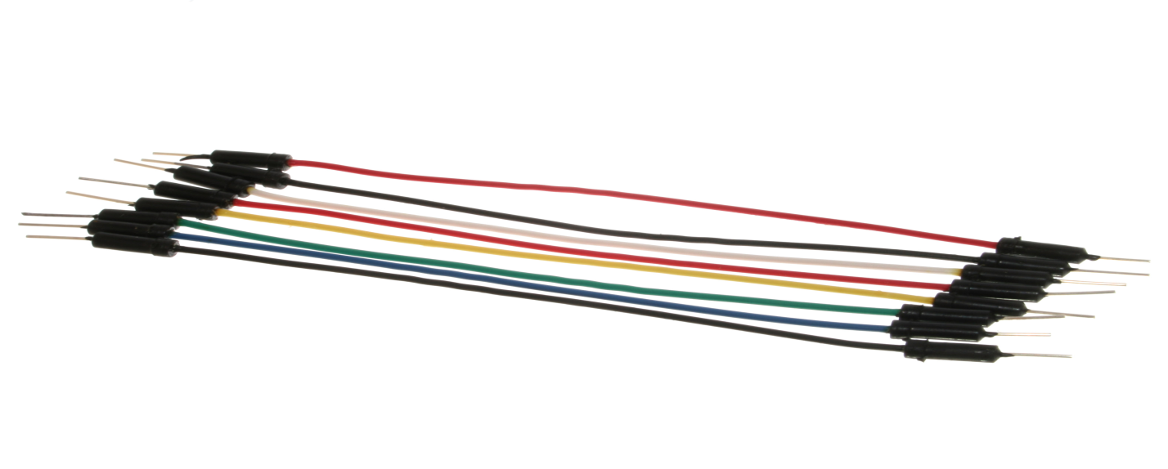

**Transistor:-**

A transistor is a [semiconductor device](https://en.wikipedia.org/wiki/Semiconductor_device) used to [amplify](https://en.wikipedia.org/wiki/Electronic_amplifier) or [switch](https://en.wikipedia.org/wiki/Switch) [electronic](https://en.wikipedia.org/wiki/Electronics) signals and [electrical power](https://en.wikipedia.org/wiki/Electrical_power). It is composed of [semiconductor](https://en.wikipedia.org/wiki/Semiconductor) material usually with at least three [terminals](https://en.wikipedia.org/wiki/Terminal_(electronics)) for connection to an external circuit. A [voltage](https://en.wikipedia.org/wiki/Voltage) or [current](https://en.wikipedia.org/wiki/Electric_current) applied to one pair of the transistor's terminals controls the current through another pair of terminals. Because the controlled (output) [power](https://en.wikipedia.org/wiki/Electric_power) can be higher than the controlling (input) power, switching purpose, a transistor can amplify a signal. Today, some transistors are packaged individually, but many more are found embedded in [integrated circuits](https://en.wikipedia.org/wiki/Integrated_circuit).

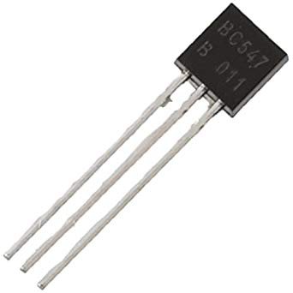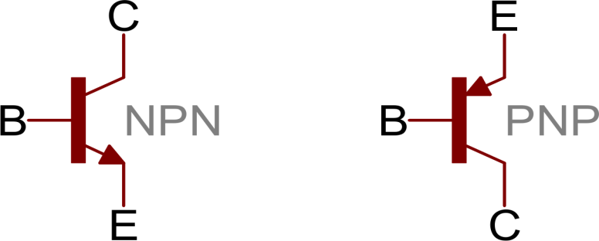

**LDR:-**

An **LDR** is a component that has a (variable) resistance that changes with the light intensity that falls upon it. This allows them to be used in light sensing circuits. The most common type of LDR has a resistance that falls with an increase in the light intensity falling upon the device. The resistance of an LDR may typically have the following resistances:

Daylight = 5000Ω

Dark = 20000000Ω

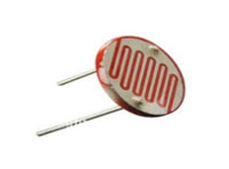

**Applications of LDRs:-**

There are many applications for Light Dependent Resistors. These include:

**Lighting switch:-**

The most obvious application for an LDR is to automatically turn on a light at a certain light level. An example of this could be a street light or a garden light.

**LED(Light Emitting Diode):-**

A light-emitting diode (LED) is a [semiconductor](https://whatis.techtarget.com/definition/semiconductor) device that emits visible light when an electric [current](https://whatis.techtarget.com/definition/current) passes through it. The light is not particularly bright, but in most LEDs it is monochromatic, occurring at a single [wavelength](https://searchnetworking.techtarget.com/definition/wavelength). The output from an LED can range from red (at a wavelength of approximately 700 nanometers) to blue-violet (about 400 nanometers). Some LEDs emit infrared (IR) energy (830 nanometers or longer); such a device is known as an infrared-emitting diode (IRED).

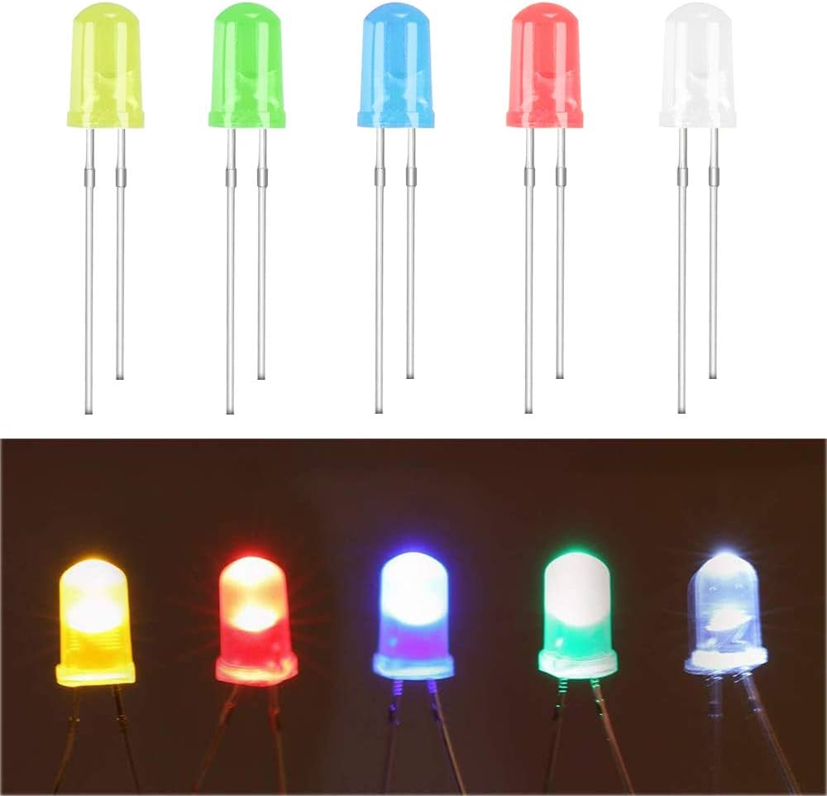

**DC Motor:-**

A DC motor is any of a class of rotary electrical machines that converts direct current electrical energy into mechanical energy. The most common types rely on the forces produced by magnetic fields. Nearly all types of DC motors have some internal mechanism, either electromechanical or electronic, to periodically change the direction of current flow in part of the motor.

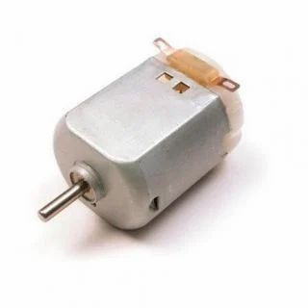

**Relay:-**

Relays are the primary protection as well as switching devices in most of the control processes or equipment. All the relays respond to one or more electrical quantities like voltage or current such that they open or close the contacts or circuits. [A relay is a switching device](https://www.elprocus.com/how-relays-work/) as it works to isolate or change the state of an electric circuit from one state to another.

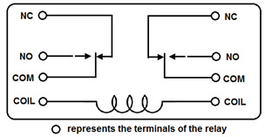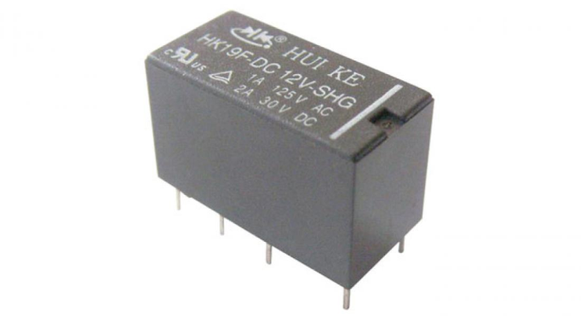

### **IR Sensor:-**

An infrared sensor is an electronic device that emits in order to sense some aspects of the surroundings. An IR sensor can measure the heat of an object as well as detects the motion. These types of sensors measures only infrared radiation, rather than emitting it that is called as a [passive IR sensor](https://www.elprocus.com/passive-infrared-pir-sensor-with-applications/). Usually in the infrared spectrum, all the objects radiate some form of thermal radiation. These types of radiations are invisible to our eyes, that can be detected by an infrared sensor. The emitter is simply an IR LED ([Light Emitting Diod](https://www.elprocus.com/explain-different-types-leds-working-applications-engineering-students/)e) and the detector is simply an IR photodiode which is sensitive to IR light of the same wavelength as that emitted by the IR LED. When IR light falls on the photodiode, the resistances and these output voltages, change in proportion to the magnitude of the IR light received.

Here we are using two types of IR sensors:

1: Logic High

2: Logic Low

